HIS FINAL STEPS LED TO A FIG TREE
Midweek Lent
Bethel Evangelical Lutheran Church | York, Nebraska
February 22, 2023
THEME OF THE DAY: HIS FINAL STEPS LED TO A FIG TREE
The theme for this year’s Lenten season is “His Final Steps.” The series will ponder the significance of the people and places on Jesus’ resolute final steps to the cross.
Worship Leader Pastor Justin Wilkens
Organist/Pianist Quinton Corwin

Acknowledgments
Software distributed in partnership with Northwestern Publishing House. Created by Christian Worship: Service Builder © 2022 Concordia Publishing House. Scripture quotations The Holy Bible, Evangelical Heritage Version® (EHV®) copyright © 2017 The Wartburg Project/NPH. All rights reserved. www.wartburgproject.org
Opening Hymn: 784 Now the Light Has Gone Away

1 Now the light has gone away;
Father, listen while I pray,
asking you to watch and keep
and to send me quiet sleep.

2 Jesus, Savior, wash away
all that I’ve done wrong today.
Make me ever more like you,
good and gentle, kind and true.

3 Let my near and dear ones be
safe with you eternally.
O bring me and all I love
to your happy home above.

4 Now my evening praise I give;
you once died that I might live.
All your precious gifts are free—
oh, how good you are to me!

5 Ah, my best and kindest Friend,
you will love me to the end.
Let me love you more and more,
always better than before.

Text: Frances R. Havergal, 1836–1879, alt.
Text: Public domain

Confession of Sins
Almighty God, our heavenly Father,
We have sinned against you
in our thoughts, in our words, in our deeds,
and in all that we have not done.
Forgive us in the name of our Lord Jesus Christ.
Deliver and restore us, that we may rest in peace.

By the mercy of God we are redeemed by Jesus Christ, and in
him we are forgiven. Let us rest in his peace until the rising
of the sun, when we shall serve him in the newness of life.
Amen.

Psalm: 4A Answer Me When I Call
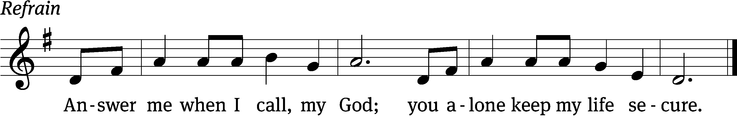
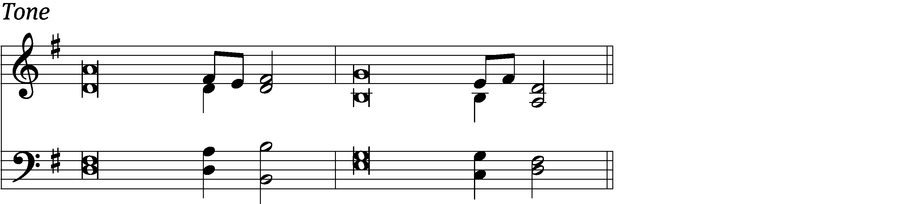

Answer me when I / call to you,
my / righteous God.
Give me relief from / my distress;
have mercy on me and / hear my prayer. Refrain

Tremble and / do not sin;
when you are on your beds, search your hearts and be / silent.
Offer the sacrifices of the / righteous
and trust / in the Lord. Refrain

Many, Lord, are asking, “Who will bring us pros- / perity?”
Let the light of your face / shine on us.
In peace I will lie / down and sleep,
for you alone, Lord, make me dwell in / safety.
Glory be to the Father and / to the Son
and to the Holy / Spirit,
as it was in the be- / ginning,
is now, and will be forever. / Amen. Refrain
Tune: Helen L. Wright
Tune: © 1986 Westminster John Knox Press. Used by permission: OneLicense no. 713578
Setting: © 2011 Faith Alive Christian Resources. Used by permission: License no. 130405222

Psalm Prayer
Grant peace to your people, Lord, that amid the stresses of life, we may rest quietly,
knowing all is right with you. Since your Son has paid for every sin, defeated every enemy, and rules at the right hand of your throne in heaven, let us fall asleep each night in peace; through Jesus Christ our Lord. Amen.
Amen.

Passion History: Matthew 26:1-35

Hymn: 631 Speak, O Savior, I Am Listening

1 Speak, O Savior, I am list’ning,
as a servant to his lord.
Let me show respect and honor
to your holy, precious Word,
that each day, my whole life through,
I may serve and follow you.
Let your Word e’er be my pleasure
and my heart’s most precious treasure.

2 Oh, what blessing to be near you
and to listen to your voice;
let me ever love and fear you,
let your Word still be my choice!
Many hardened sinners, Lord,
flee in terror at your Word;
but to all who feel sin’s burden
you give peace and words of pardon.
3 Lord, your words are waters living
where I quench my thirsty needs.
Lord, your words are bread life-giving;
on your words my spirit feeds.
Lord, your words will be my light
thro’ death’s cold and dreary night;
yes, they are my sword prevailing
and my cup of joy unfailing.

4 As I pray, dear Jesus, hear me;
let your words in me take root.
May your Spirit e’er be near me
that I bear abundant fruit.
May I daily sing your praise,
from my heart glad anthems raise,
till my highest praise is given
in the endless joy of heaven.

Text: Anna Sophia von Hessen-Darmstadt, 1638–1683; (sts. 1, 4): tr. Christian Worship, 1993; (sts. 2–3): tr. George A. T. Rygh, 1860–1942, alt.
Text: Public domain

Sermon
Reading Mark 11:12–14, 20–25
Jesus Curses a Fig Tree and Clears the Temple Courts
¹² The next day, after they had set out from Bethany, Jesus was hungry. ¹³ When he saw a fig tree in leaf in the distance, he went to see if he might find anything on it. When he came to it, he found nothing but leaves, since it was not the season for figs. ¹⁴ Jesus said to it, “May no one ever eat fruit from you again!” And his disciples were listening. ²⁰ As they passed by in the morning, they saw the fig tree withered down to the roots. ²¹ Peter remembered and said, “Rabbi, look! The fig tree that you cursed has withered.”
²² Jesus replied, “Have faith in God. ²³ Amen I tell you: Whoever says to this mountain, ‘Be lifted up and thrown into the sea,’ and does not doubt in his heart, but believes that what he says will happen, it will be done for him. ²⁴ Therefore I tell you, everything that you ask for in prayer, believe that you have received it, and it will be yours. ²⁵ Whenever you stand praying, if you have anything against anyone, forgive him, so that your Father in heaven may forgive you your sins.

Offering
Offering Hymn: 400 Sweet the Moments, Rich in Blessing sts. 1, 5

1 Sweet the moments, rich in blessing,
which before the cross we spend,
life and health and peace possessing
from the sinner’s dying friend.

5 Lord, in loving contemplation
fix our hearts and eyes on you
till we taste your full salvation
and your unveiled glory view.

Text: alt. Walter Shirley, 1725–1786; James Allen, 1734–1804
Text: Public domain

Prayer
Gracious Lord, according to your will and promise,
You sent your Son into our world to atone for sin and restore eternal life.
You planned his path to the cross,
and he followed it perfectly.
He confronted the blindness of unbelief, the confusion of doubt, and the hurt of death
but was not deterred as he proclaimed your kingdom to the least, the last, and the lost.
As we hear and contemplate the holy record of our Savior’s passion and death,
Use the sharp message of the law to empty us of pride and self-reliance.
Humble us as we view the Savior in his humility,
remembering and believing that he endured the cross so we might be freed from its horror.
In his suffering show us our healing,
in his grief show us our joy,
and in his death show us our life.
Hear our prayers, Lord, for the sake of Jesus. Amen.

Lord’s Prayer
Our Father, who art in heaven,
hallowed be thy name,
thy kingdom come,
thy will be done
on earth as it is in heaven.
Give us this day our daily bread;
and forgive us our trespasses,
as we forgive those
who trespass against us;
and lead us not into temptation,
but deliver us from evil.
For thine is the kingdom
and the power and the glory
forever and ever. Amen.

Blessing
May God be gracious to us and bless us and make his face shine on us.
May God bless us still, so that all the ends of the earth will fear him.

Hymn: 695 Take My Life and Let It Be

1 Take my life and let it be
consecrated, Lord, to thee;
take my moments and my days,
let them flow in ceaseless praise.

2 Take my hands and let them move
at the impulse of thy love;
take my feet and let them be
swift and beautiful for thee.

3 Take my voice and let me sing
always, only for my King;
take my lips and let them be
filled with messages from thee.

4 Take my silver and my gold,
not a mite would I withhold;
take my intellect and use
ev’ry pow’r as thou shalt choose.

5 Take my will and make it thine,
it shall be no longer mine;
take my heart, it is thine own,
it shall be thy royal throne.

6 Take my love, my Lord, I pour
at thy feet its treasure store;
take myself, and I will be
ever, only, all for thee.

Text: Frances R. Havergal, 1836–1879
Text: Public domain

